Jaipur Engineering College & Research Centre, Jaipur



# Sports Report (2023-2024)

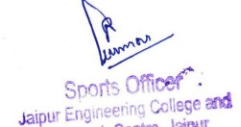

## Badminton (Boys)

Our JECRC Students got 1st position in RTU Inter College Tournament held at SKIT College dated on 06/11/2023 to 08/11/2023

Following students were participated in this BADMINTON-TEAM

1. Naman sahay Bhatnagar IV Year
2. Rman Agarawal IV Year
3. Madhav Saraswat III Year
4. Tushar Dhaker I Year
5. Milan Sain I Year

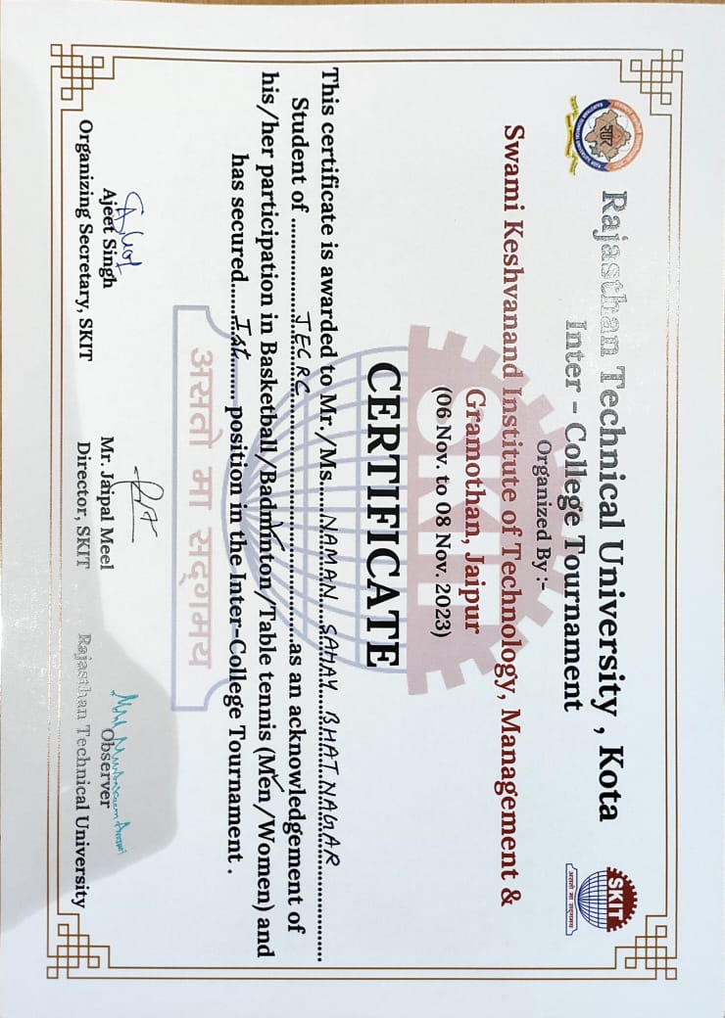

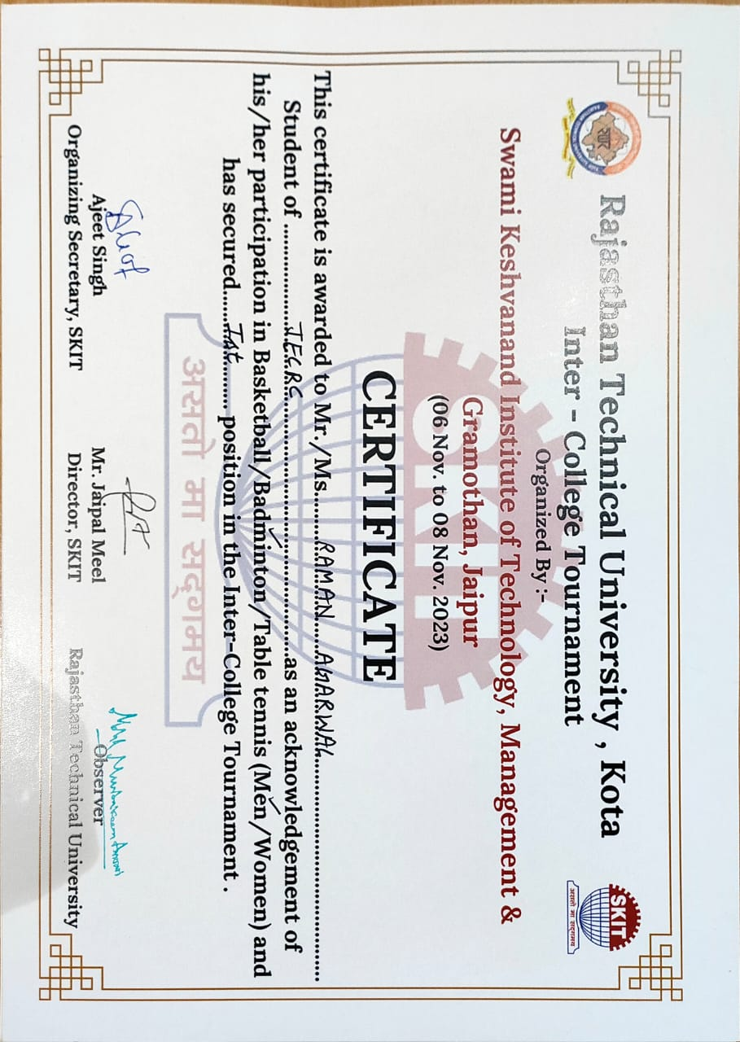

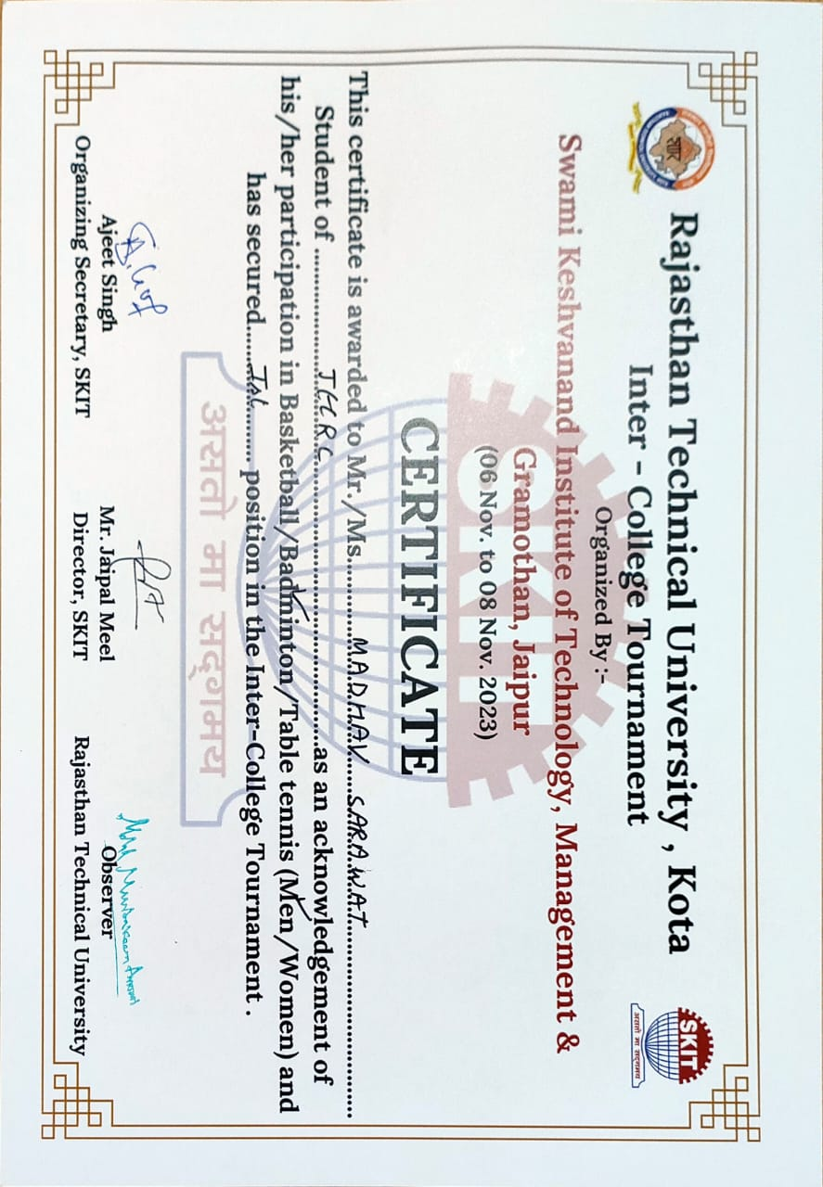

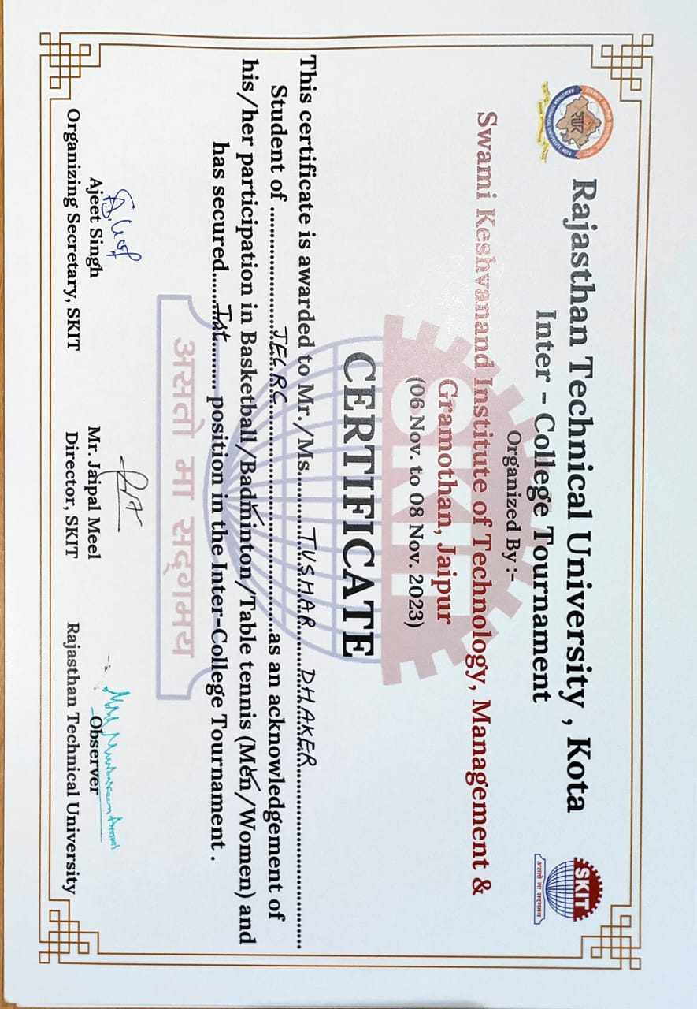

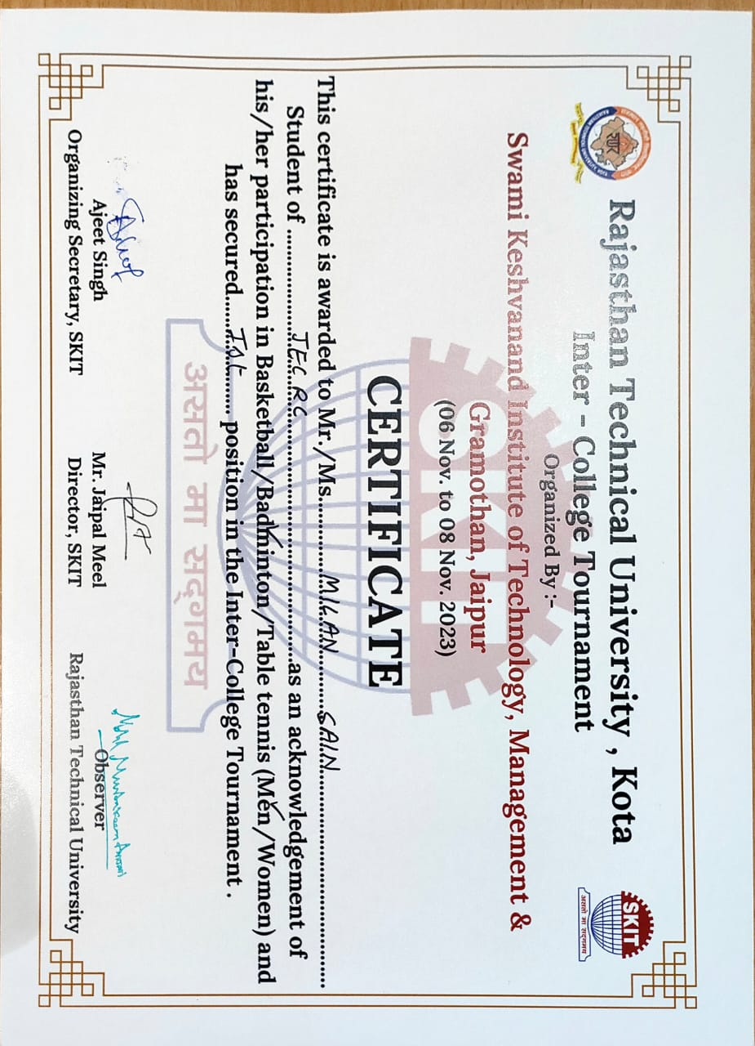

## Badminton (Boys Doubles)

Our JECRC Students got 1st position in LAMHE 2023 an Inter College Fest held

On December 15 and 16 , 2023 at TAXILA BUSINESS SCHOOL, Jaipur

1. Tushar Dhaker I Year
2. Aman Agrawal I Year

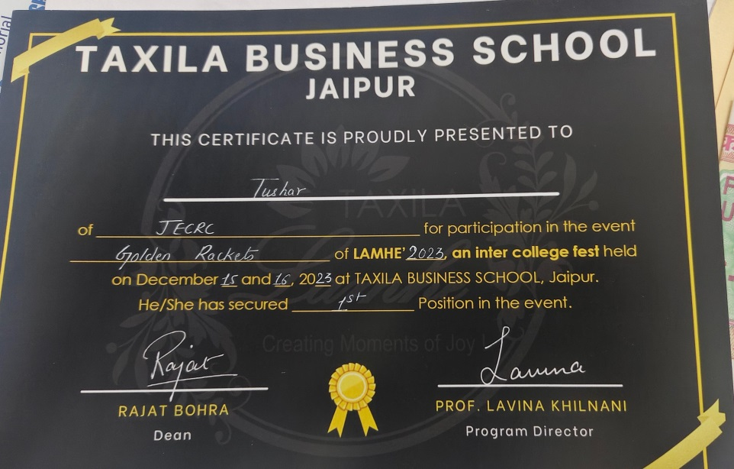

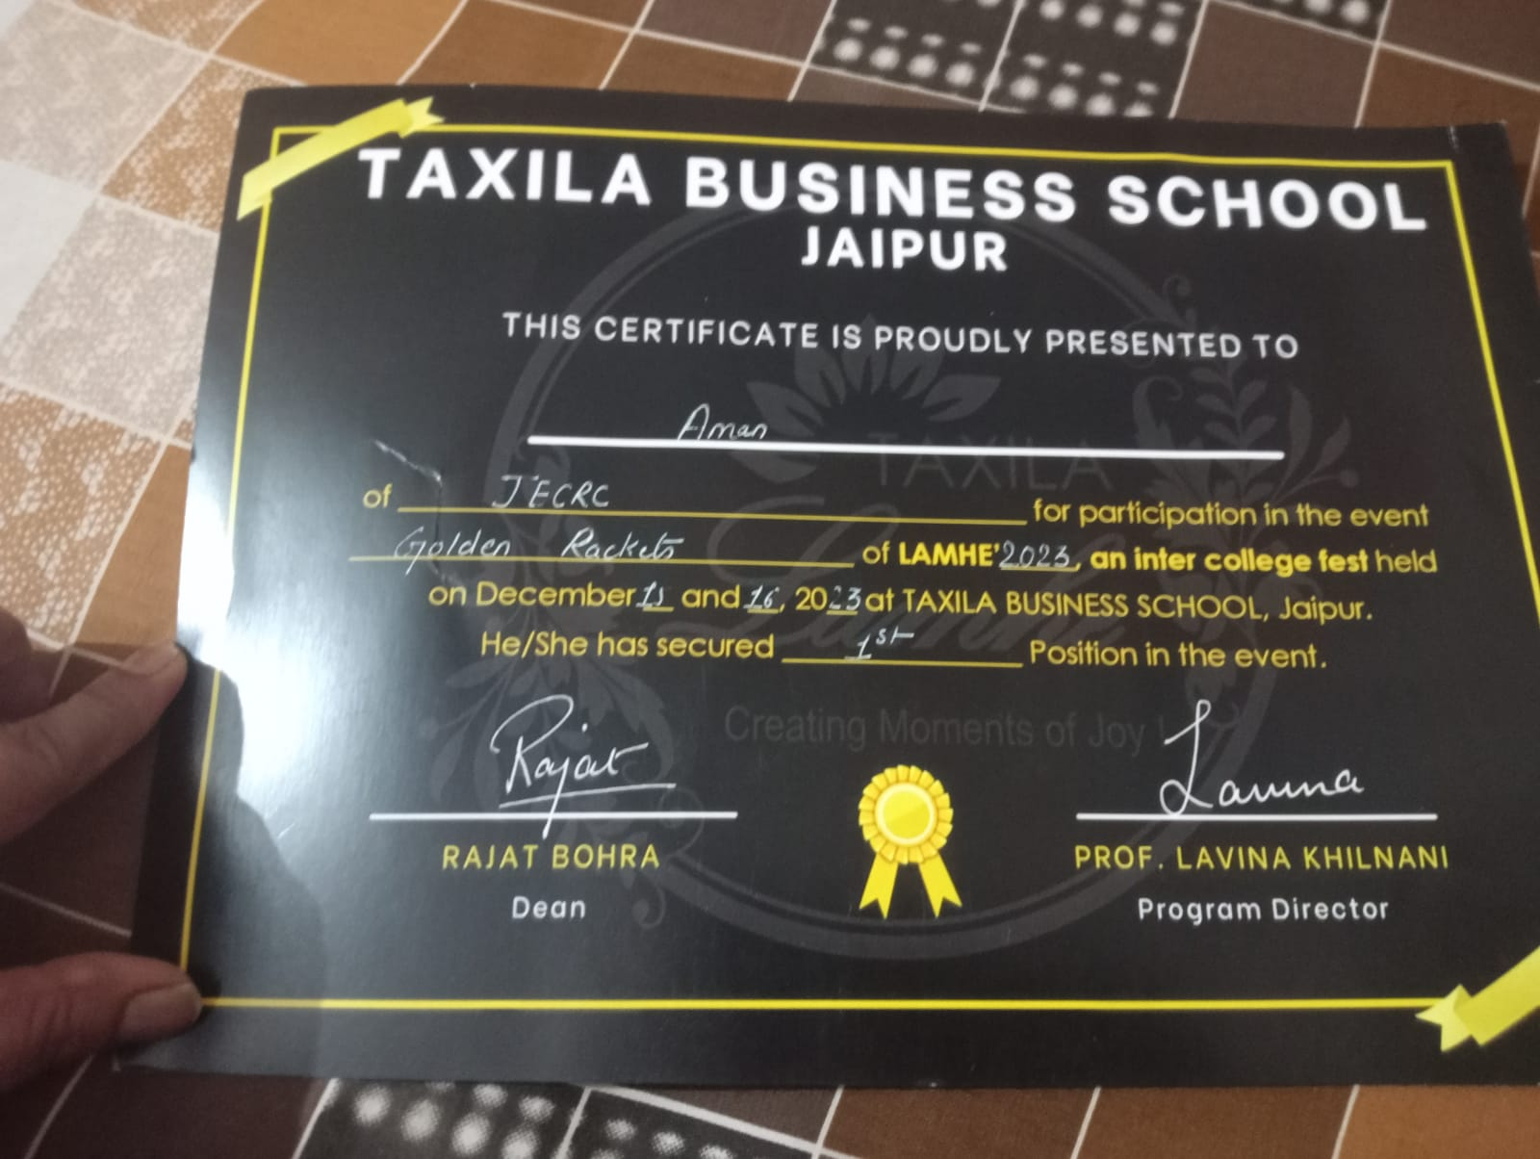

## BasketBall (Boys)

Our JECRC Students participated in RTU Inter College Tournament at SKIT College

dated on 06/11/2023 to 08/11/2023

Following students were participated in this BASKETBALL-TEAM

1. Yashovardhan Singh Rathore 1st year
2. Krishna Pratap Singh Shaktawat 4th year
3. Dinesh Meena 3rd year
4. Harshvardhan Singh Rathore 2nd year
5. Jatin Chaudhary 1st year
6. Hardik Chordiya 3rd year
7. Chirag Jain 4th year

## BasketBall (Girls)

Our JECRC Students participated in RTU Inter College Tournament held at SKIT College

dated on 06/11/2023 to 08/11/2023

Following students were participated in this BASKETBALL-GIRLS TEAM

1. Pal chaplot 1st year
2. Khushboo malpani 3rd year
3. Janvi motwani 4th year
4. Bharti somra 4th year
5. Charul saini 3rd year
6. Garvita 4th year
7. Gauri 4th year

## Football (Boys)

Our JECRC Students got 2nd position in RTU Inter College Tournament held at Poornima University dated on 28/11/2023 to 30/11/2023

Following students were participated in this FootBall Boys TEAM-

1. Dhruv 2nd year
2. Robin 2nd year
3. Harshit 2nd year
4. Raghav 2nd year
5. Raman 2nd year
6. Kartik 2nd year
7. Parth 2nd year
8. Vaibhav 2nd year
9. Nikhil 3rd year
10. Dhananjay 3rd year
11. Abhinav 3rd year
12. Mihar 3rd year
13. Yuvraj 4th year
14. Manav 4th year
15. Arin 1st year
16. Rachit 1st year

## Volleyball (Boys)

Our JECRC Students participated in RTU Inter College Tournament held at GIT College

Dated on 20 nov 2023 to 22 nov 2023.

Following students were participated in this Volleyball Boys TEAM-

1. Arman 3rd Year
2. Kuldeep latta 3rd Year
3. Amit 1st Year
4. Akshay Chaudhary 4th Year
5. Chanderkant jangid 2nd Year
6. Rudra Pratap singh 2nd Year
7. Aryaan suwalkar 2nd Year
8. Garv 2nd Year
9. TUSHAR  1ST Year
10. Nikhil  3rd Year

## West-Zone Players (Boys & Girls)

Our JECRC Students represented RTU University in West-Zonal Tournament in 2023.

Here are the list of following students who represented in different sports-

1. Arman 3rd Year , Event(Volleyball)

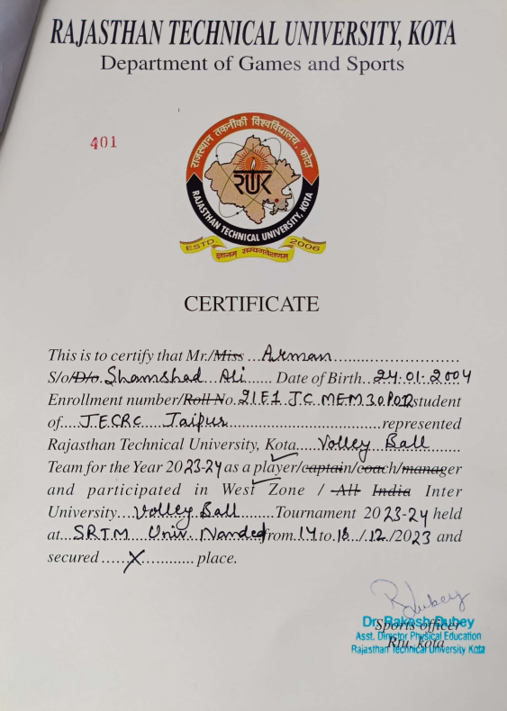

1. Krishan Pal Singh Shaktawat 4th Year , Event(Basketball)

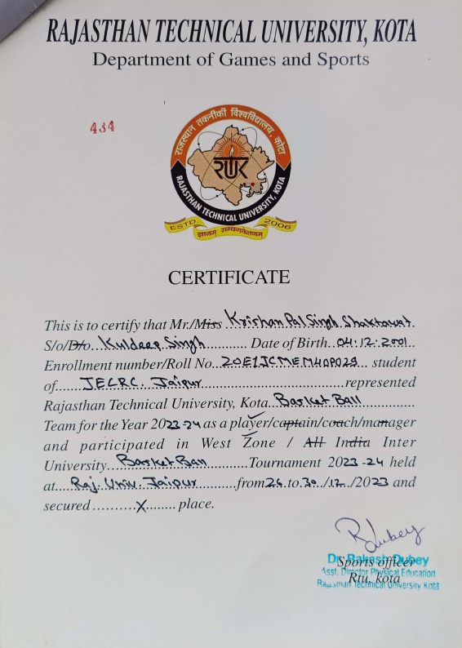

1. Naman Sahay Bhatnagar 4th Year , Event(Badminton)

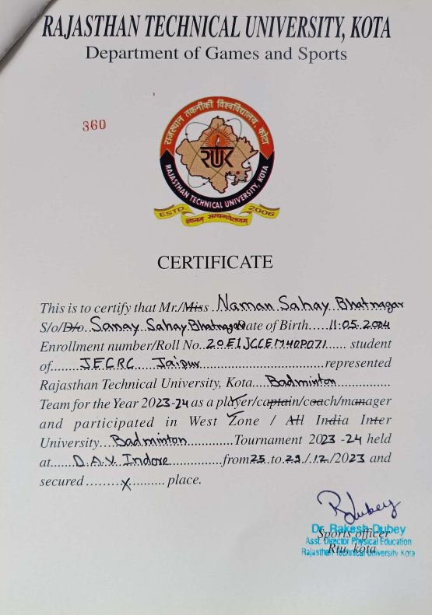

1. Tushar Dhaker 1st Year , Event(Badminton)

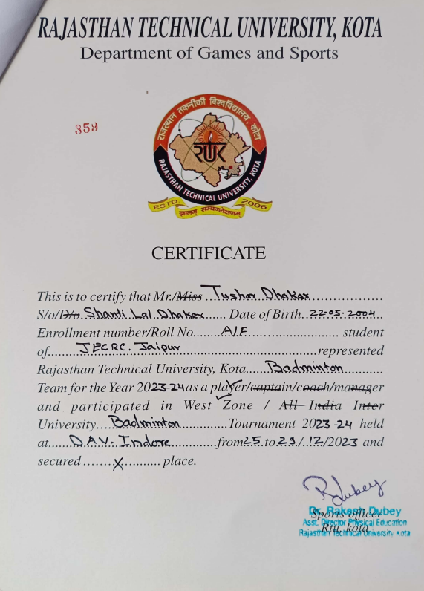

1. Janvi Motwani 4th Year , Event(Basketball)

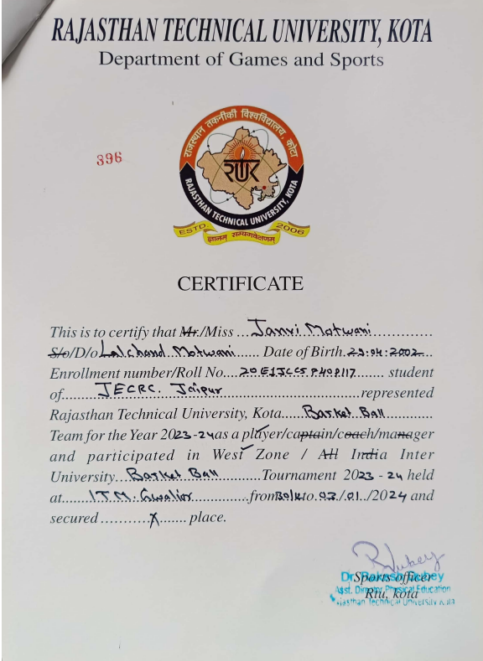

1. Khushboo Malpani 3rd Year , Event(BasketBall)

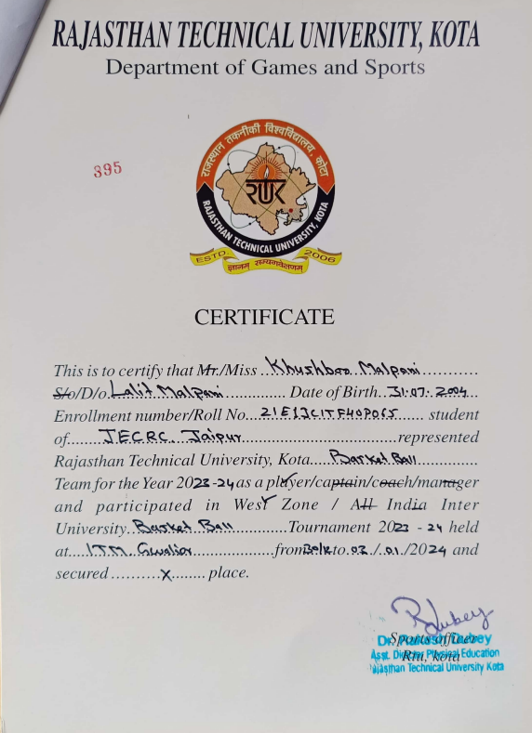

1. Dhruv Nehra 2nd Year , Event(Football)

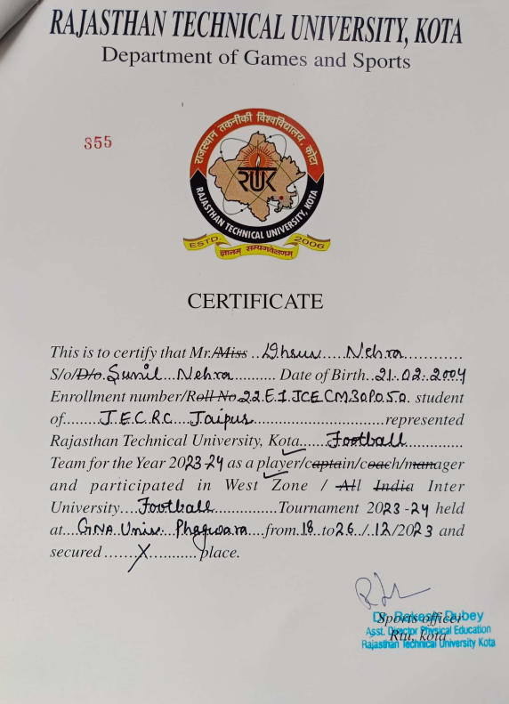

1. Parth Sharma Year , Event(Football)

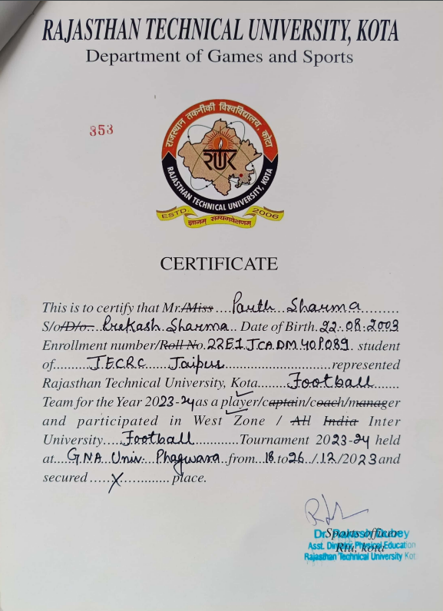

1. Raman Saxena Year , Event(Football)

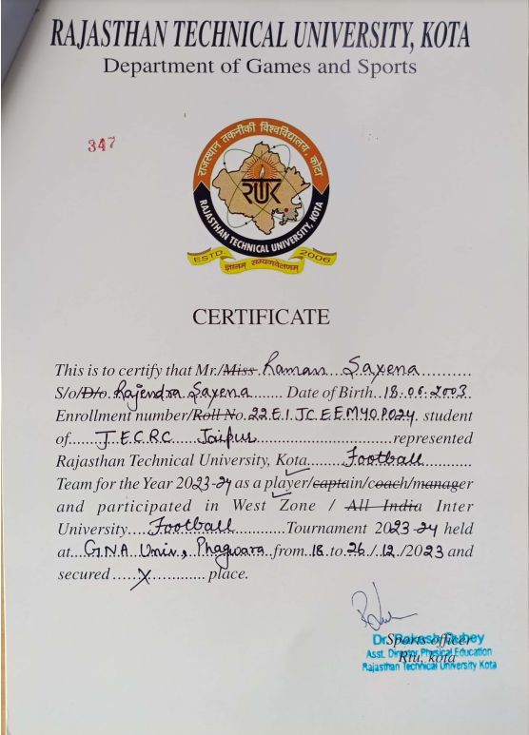

## Memories

